Final Report

Date | 04 July 2026
Team ID | SWTID-2026-4563
Project Name | Visualizing Housing Market Trends: An Analysis of Sale Prices and Features using Tableau
Maximum Marks | 5 Marks

Table of Contents:

S.NO | Contents | Page No
1. | Introduction | 2-3
2. | Ideation Phase | 4-7
3. | Requirement Analysis | 8-11
4. | Project Design | 12-13
5. | Project Planning & Scheduling | 14
6. | Functional and Performance Testing | 15
7. | Results | 16-19
8. | Advantages and Disadvantages | 20-21
9. | Conclusion | 22
10. | Future Scope | 22
11. | Appendix | 23

Introduction

Project Overview:
The project “Visualizing Housing Market Trends” aims to analyze and present housing market data in a meaningful and interactive manner. Housing market datasets are often large, complex, and difficult to interpret using traditional methods such as spreadsheets or static reports. This project addresses that challenge by transforming raw housing data into visual insights that highlight trends, patterns, and relationships between house prices and key features.
The project follows a structured workflow starting from dataset collection and data preprocessing to visualization and dashboard creation. Housing market data is cleaned and prepared using Python-based data processing techniques. The processed data is then used to create visualizations and dashboards using…
The project “Visualizing Housing Market Trends” is designed to analyze housing market data and present meaningful insights through interactive visualizations. Housing market datasets typically contain a large number of records with multiple attributes such as location, sale price, size, number of rooms, and other features. Analyzing such datasets using traditional methods like spreadsheets or static reports is time-consuming and often fails to provide clear insights.
This project addresses these challenges by applying data preprocessing, visualization, and dashboard techniques to convert raw housing data into easily understandable visual formats. The workflow begins with dataset collection from reliable sources, followed by data cleaning and preprocessing to ensure accuracy and consistency. Preprocessing steps include handling missing values, removing duplicate records, correcting data types, and preparing the dataset for analysis.
After preprocessing, the cleaned data is used to create visualizations using Tableau Desktop. Tableau enables the creation of charts, graphs, and dashboards that help in identifying housing price trends, regional variations, and the impact of different features on house prices. These visualizations make it easier to explore patterns that are difficult to detect in raw data.
To improve accessibility and usability, the Tableau dashboard is integrated with a Flask-based web application. Flask acts as a lightweight backend framework that serves the dashboard through a web interface. This integration allows users to view analytical insights using a browser without directly interacting with Tableau Desktop. The project does not include user authentication or transactional features; instead, it focuses purely on data analysis and visualization.
Overall, this project demonstrates how data analytics tools and web technologies can be combined to build an effective analytical system. It is primarily intended for academic learning and project demonstration purposes, helping students understand real-world data analysis workflows.

Purpose:
The primary purpose of this project is to simplify the understanding of housing market trends by representing complex datasets in a visual and interactive manner. Housing data often contains hidden patterns that are difficult to identify through manual analysis. By using visualization techniques, the project helps highlight trends, comparisons, and relationships between different housing attributes.
Another important purpose is to support data-driven analysis. Instead of relying on assumptions or manual calculations, the project enables structured exploration of housing prices and features using dashboards. This approach improves clarity and reduces the effort required to interpret large datasets.
The project also aims to provide practical exposure to modern data analysis tools and technologies. Students gain hands-on experience in data preprocessing using Python, creating professional dashboards with Tableau Desktop, and integrating analytical outputs with a web application using Flask. This combination of skills is highly relevant in the fields of data analytics, business intelligence, and software development.
From an academic perspective, the project serves as a learning-oriented analytical system rather than a commercial product. It helps demonstrate how raw data can be transformed into useful insights through a structured process. Additionally, the project promotes better decision-making by presenting data in a clear and understandable format, which can be useful for academic analysis, research, and educational demonstrations.
In summary, the purpose of the project is not only to visualize housing market data but also to showcase the complete lifecycle of a data analytics project—from data collection and preprocessing to visualization and web-based presentation.

Ideation Phase

Problem Statement:
Customer Problem Statement Template:

Problem Statement (PS) | I am | I’m trying to | But | Because | Which makes me feel
PS-1 | A home buyer | to understand housing price trends and key features affecting prices | housing data is large, complex, and difficult to interpret | prices vary based on location, size, amenities, and time | confused and unsure while making purchase decisions
PS-2 | A  property investor | find profitable investment locations | I lack visual tools to compare trends across regions | manual analysis takes too much time | hesitant to invest

Problem Statement (PS)-1
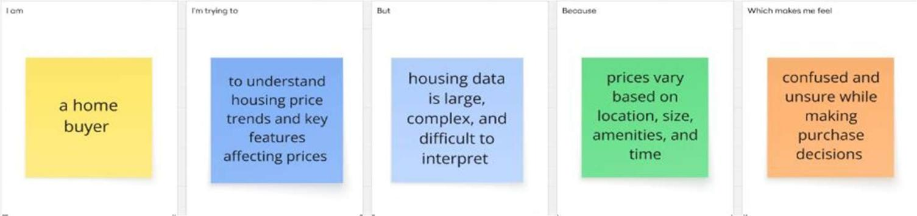

Problem Statement (PS)-2
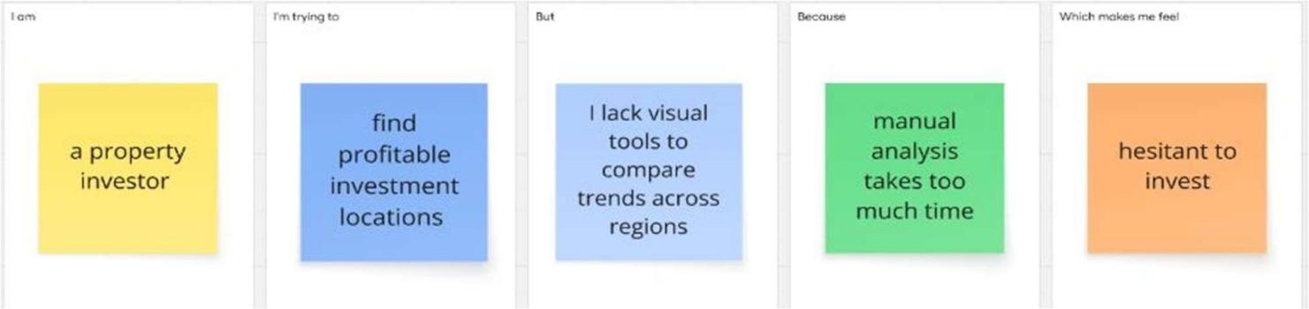

Empathy Map
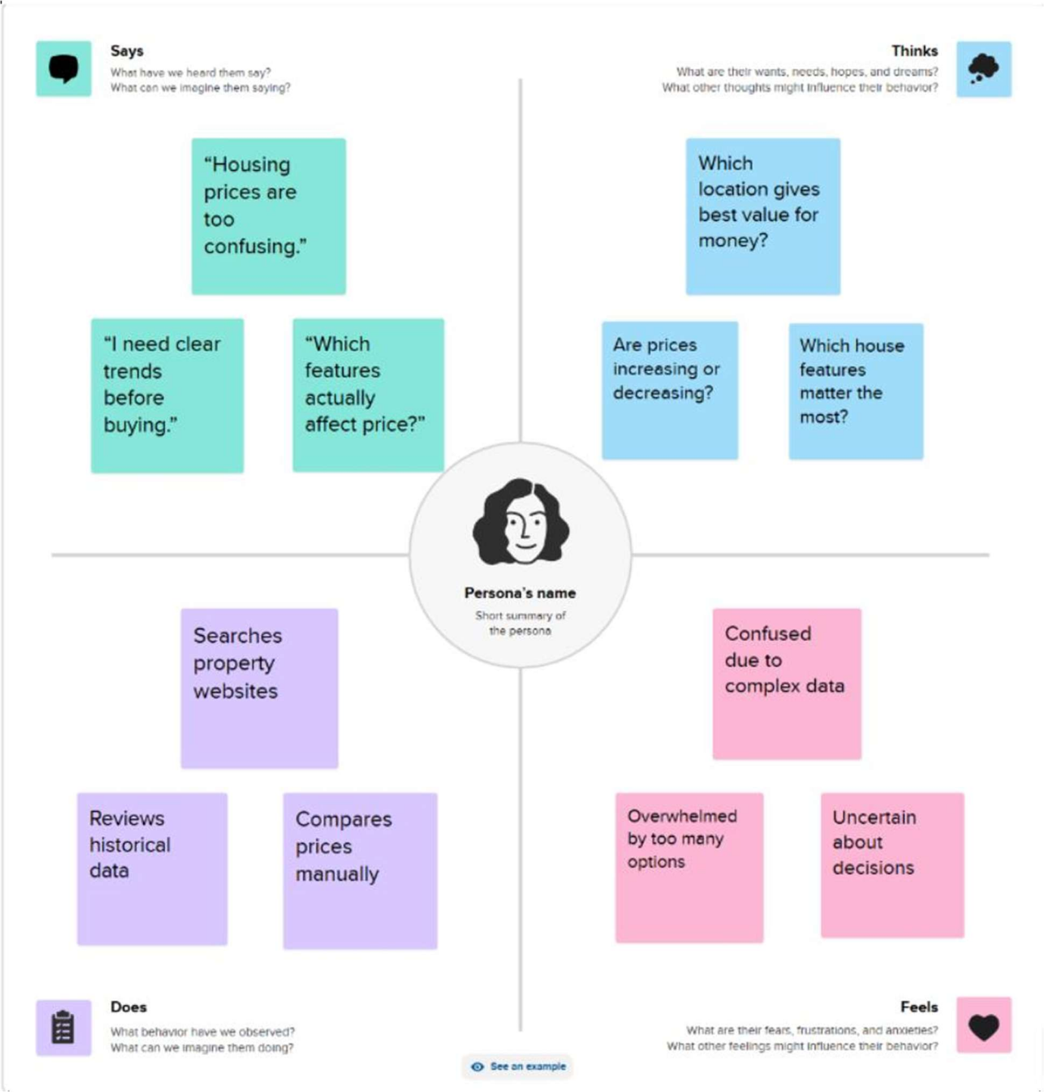

Brainstorming:
Step-1: Team Gathering, Collaboration and Select the Problem Statement
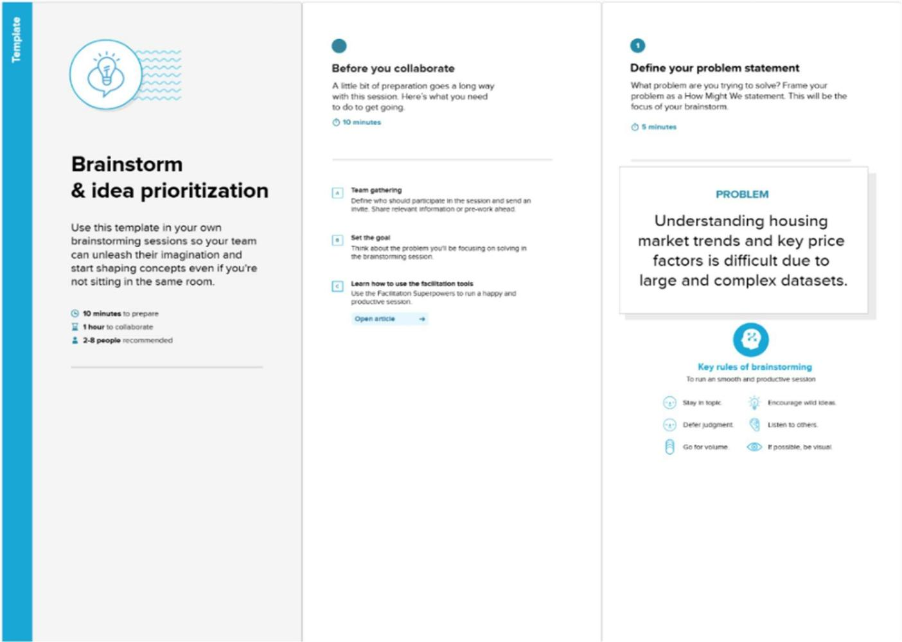
Step-2: Brainstorm, Idea Listing and Grouping
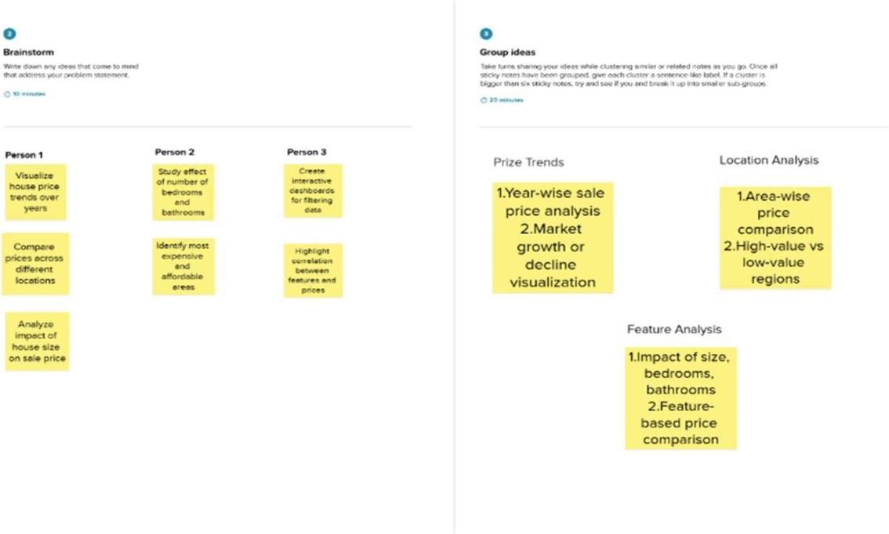

Step-3: Idea Prioritization
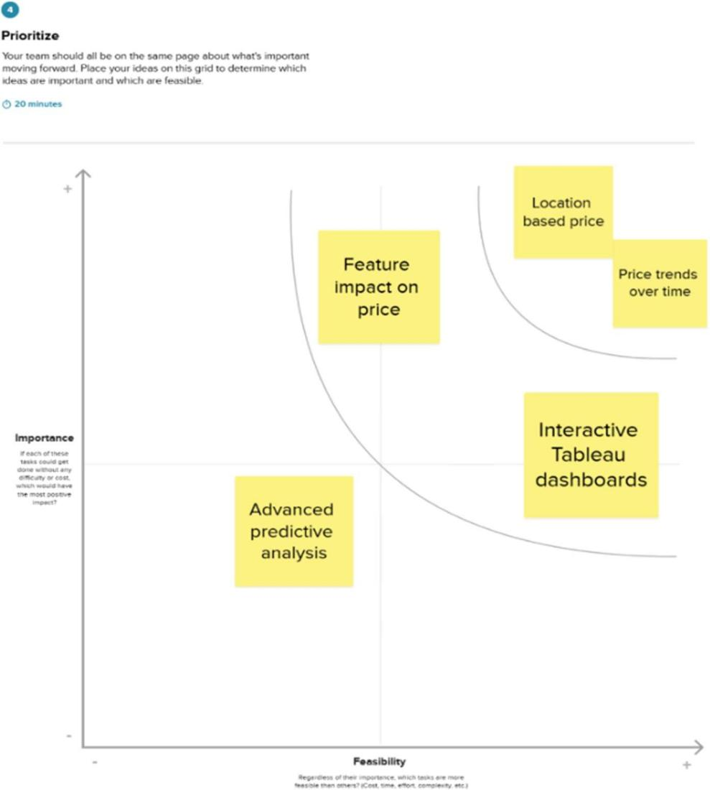

Requirement Analysis

Customer Journey map:
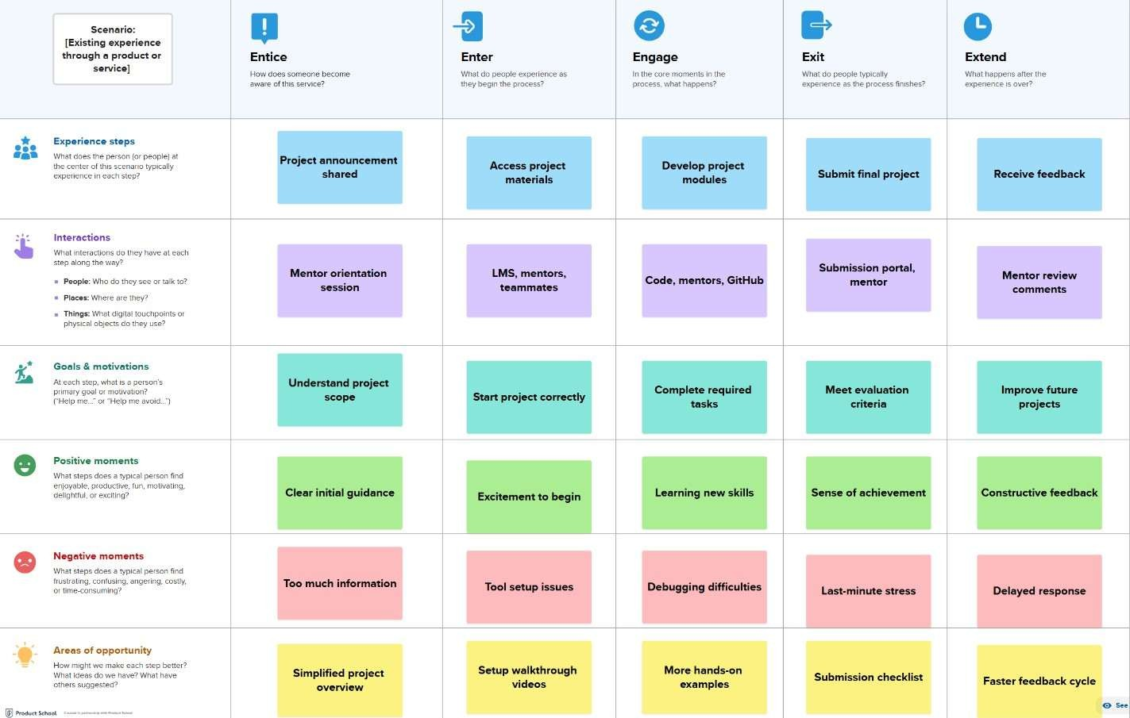

Solution Requirement:
Functional Requirements:

FR No. | Functional Requirement (Epic) | Sub Requirement (Story / Sub-Task)
FR-1 | Data Collection | Import housing dataset (CSV/Excel)
FR-2 | Data Cleaning | Handle missing values, remove duplicates
FR-3 | Data Preparation | Create calculated fields, filters
FR-4 | Feature Analysis | Compare price vs location, size, rooms
FR-5 | Interactive Dashboards | Filters for location, price range
FR-6 | Visualization Creation | Bar charts, line charts, maps
FR-7 | Insight Generation | Identify key price influencing factors
FR-8 | Dashboard Publishing | Share Tableau dashboard online

FR-9 | User Interaction | View, filter, explore insights
Non-functional Requirements:

FR No. | Non-Functional Requirement | Description
NFR-1 | Usability | Dashboards should be easy to understand with clear charts and filters
NFR-2 | Security | Housing dataset should be protected from  unauthorized modifications
NFR-3 | Reliability | Visualizations should consistently show correct data  insights
NFR-4 | Performance | Dashboard should load and respond quickly to user interactions
NFR-5 | Availability | Tableau dashboard should be accessible whenever required
NFR-6 | Scalability | Dashboard should support additional housing data in the future

Data Flow Diagram:

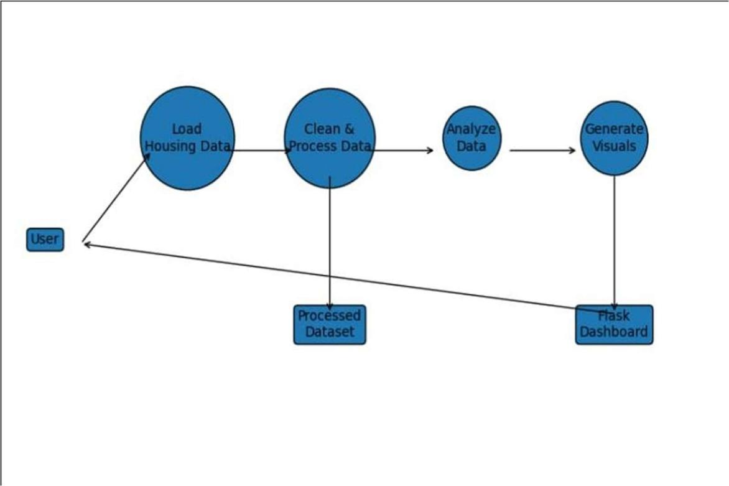

User Stories:

User Type | Functional Requirement (Epic) | User Story Number | User Story / Task | Acceptance criteria | Priority | Release
User (Analyst) | Data Loading | USN-1 | As a user, I can load a  housing dataset into the system | Dataset loads without errors | High | Sprint-1
User (Analyst) | Data Processing | USN-2 | As a user, I can preprocess and clean housing data | Cleaned data  available for analysis | High | Sprint-1
User (Analyst) | Visualization | USN-3 | As a user, I can generate visualizations for price trends and features | Charts render correctly | High | Sprint-1
User (Viewer) | Dashboard Access | USN-4 | As a user, I can access the dashboard through a Flask web interface | Dashboard loads in browser | High | Sprint-2
User (Viewer) | Interactivity | USN-5 | As a user, I can filter data on the dashboard | Dashboard  updates dynamically | Medium | Sprint-2
User (Viewer) | Insight Viewing | USN-6 | As a user, I can view insights and summaries | Insights are clearly displayed | Medium | Sprint-2

Technology Stack:
Technical Architecture:
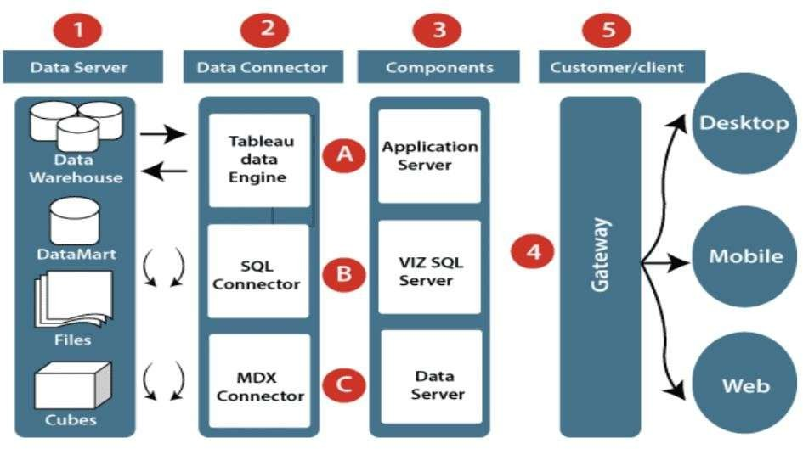

Table-1: Components & Technologies:

S.No | Component | Description | Technology
1. | User Interface | How user interacts with application e.g.  Web UI, Mobile App, Chatbot etc. | Flask, HTML, CSS
2. | Application Logic-1 | Logic for a process in the application | Python
3. | Application Logic-2 | Logic for a process in the application | -
4. | Application Logic-3 | Logic for a process in the application | -
5. | Database | Data Type, Configurations etc. | -
6. | Cloud Database | Database Service on Cloud | -
7. | File Storage | File storage requirements | Local Filesystem
8. | External API-1 | Purpose of External API used in the application | -
9. | External API-2 | Purpose of External API used in the application | -
10. | Tableau | Purpose of Machine Learning Model | Tableau Desktop/Public  2025.3.2
11. | Infrastructure (Server / Cloud) | Application Deployment on Local System / Cloud  Local Server Configuration: Cloud Server Configuration: | Local.

Table-2: Application Characteristics:

S.No | Characteristics | Description | Technology
1. | Open-Source Frameworks | List the open-source frameworks used | Tableau public, Flask, VS code, Tableau prep Builder
2. | Security Implementations | List all the security / access controls implemented, use of firewalls etc. | -
3. | Scalable Architecture | Justify the scalability of architecture (3 – tier, Micro-services) | -
4. | Availability | Justify the availability of application  (e.g. use of load balancers, distributed servers etc.) | Available whenever server runs
5. | Performance | Design consideration for the performance of the application  (number of requests per sec, use of Cache, use of CDN’s) etc. | Fast data processing and loading

Project Design

Problem Solution Fit:
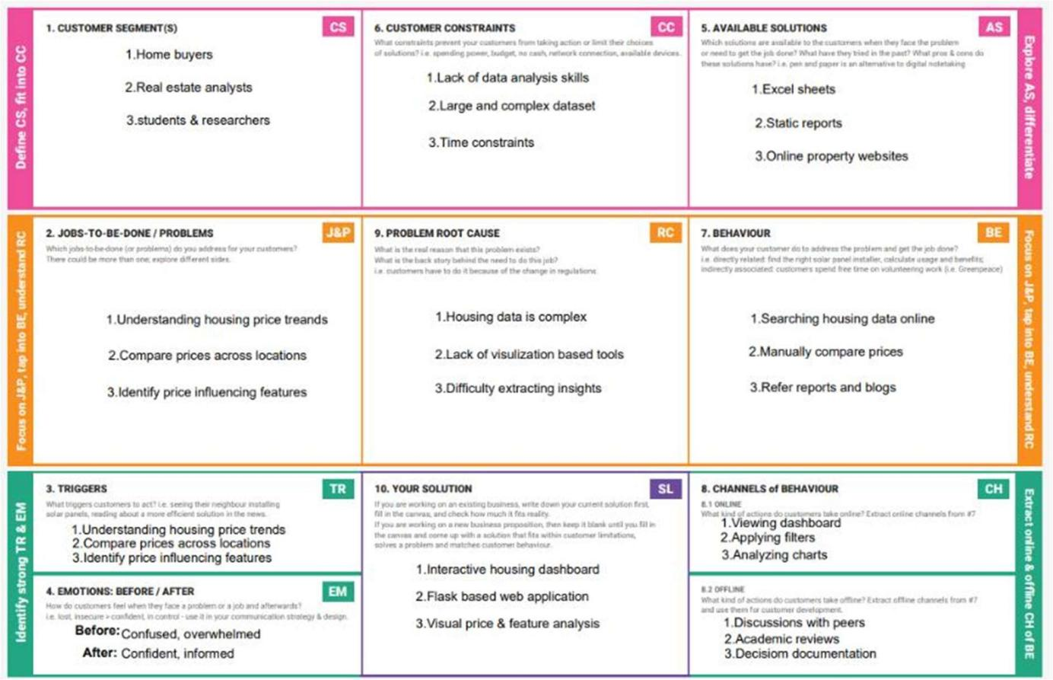

Proposed Solution:

S.No. | Parameter | Description
1. | Problem Statement (Problem to be solved) | Understanding housing price trends is difficult due to large and complex datasets.
2. | Idea / Solution description | An interactive Flask-based dashboard to visualize housing market trends.
3. | Novelty / Uniqueness | Combines data visualization with a simple web dashboard.
4. | Social Impact / Customer Satisfaction | Helps users make informed housing decisions easily.
5. | Business Model (Revenue Model) | Academic and research-based usage.

6. | Scalability of the Solution | Can support additional datasets and features.

Solution Architecture:
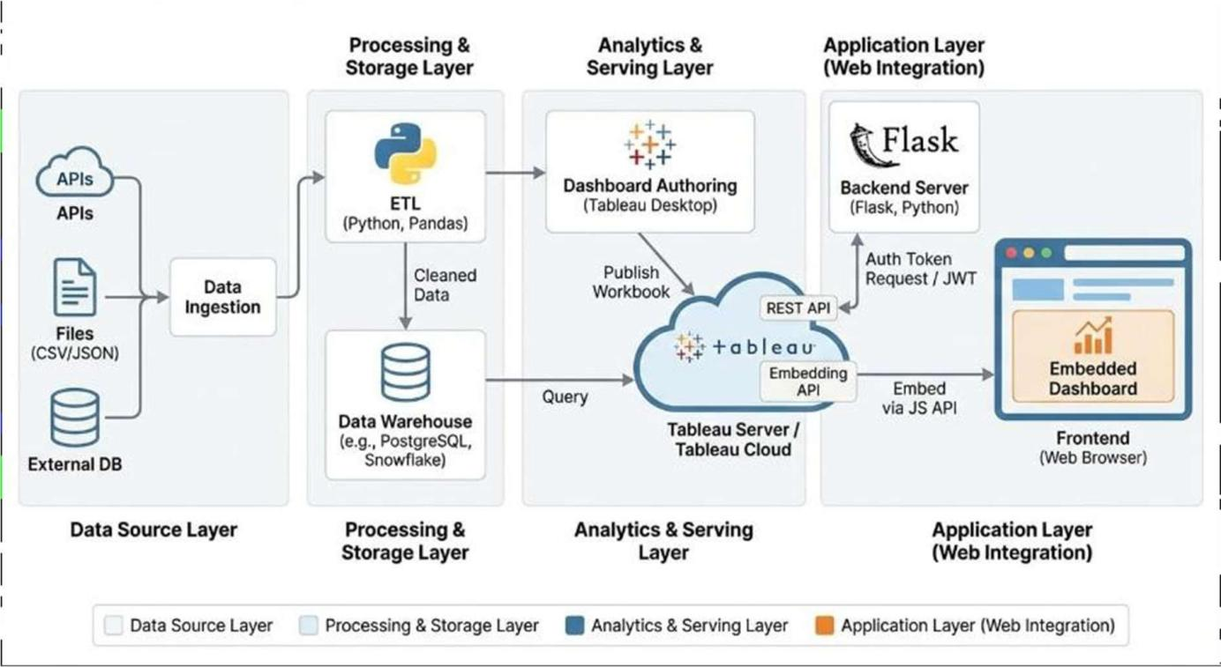
Figure 1: Architecture of Python-Tableau-Flask Integrated Data Stack

Project Planning & Scheduling

Project Planning:

Sprint | Functional Requirement (Epic) | User Story Number | User Story / Task | Story Points | Priority | Team Members
Sprint-1 | Dataset Collection | USN-1 | As a developer, I can collect housing market dataset from reliable sources | 2 | High | Team
Sprint-1 | Data Cleaning | USN-2 | As a developer, I can clean the dataset by handling missing and inconsistent values | 4 | High | Team
Sprint-1 | Data Preprocessing | USN-3 | As a developer, I can preprocess data for analysis and  visualization | 4 | High | Team
Sprint-2 | Data Storage | USN-4 | As a developer, I can store the processed data in structured format (CSV) | 3 | Medium | Team
Sprint-2 | Data Visualization | USN-5 | As a developer, I can create housing market  Visualizations using Tableau Desktop | 5 | High | Team
Sprint-2 | Dashboard  Creation | USN-6 | As a developer, I can build an  interactive Tableau dashboard | 4 | High | Team
Sprint-3 | Web Integration | USN-7 | As a developer, I can integrate the Tableau dashboard with Flask | 5 | High | Team
Sprint-3 | Deployment | USN-8 | As a developer, I can deploy the Flask application locally | 3 | Medium | Team
Sprint-4 | Template understanding | USN-9 | As a developer, I can understand the assigned project templates | 2 | High | Team
Sprint-4 | Templates Filling | USN-10 | As a developer, I can fill the assigned templates with project  details | 4 | High | Team

Project Tracker, Velocity & Burndown Chart:

Sprint | Total  Story Points | Duration | Sprint Start Date | Sprint End Date (Planned) | Story Points Completed | Sprint Release Date (Actual)
Sprint-1 | 20 | 3 Days | 30 Jan 2026 | 01 Feb 2026 | 20 | 01 Feb 2026
Sprint-2 | 20 | 5 Days | 01 Feb 2026 | 08 Feb 2026 | 20 | 08 Feb 2026
Sprint-3 | 20 | 4 Days | 09 Feb 2026 | 12 Feb 2026 | 20 | 12 Feb 2026
Sprint-4 | 20 | 6 Days | 13 Feb 2026 | 18 Feb 2026 | 20 | 18 Feb 2026

Functional and Performance Testing

Performance Testing:

S.No. | Parameter | Screenshot / Values
1. | Data Rendered | 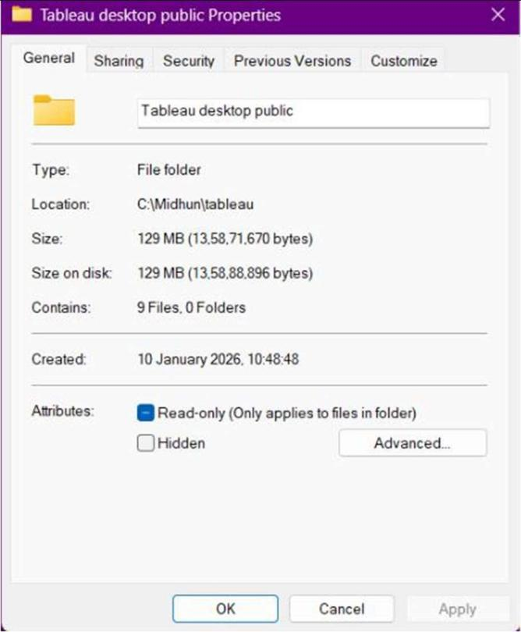
2. | Data Preprocessing | - One of the residents type is null changed that to Five Families.  - One of the town data is null changed it to Antalya.  - Removed unwanted fields.
3. | Utilization of Filters | List Year, Resident Type, Property Type
4. | Calculation fields Used | -
5. | Dashboard design | Bar, TreeMap, Line, Side-By-Side Bar, Area charts, dual combinations, Packed Bubbles
6 | Story Design | Bar, TreeMap, Line, Side-By-Side Bar, Area charts, dual combinations, Packed Bubbles.  As DashBoards.

Results

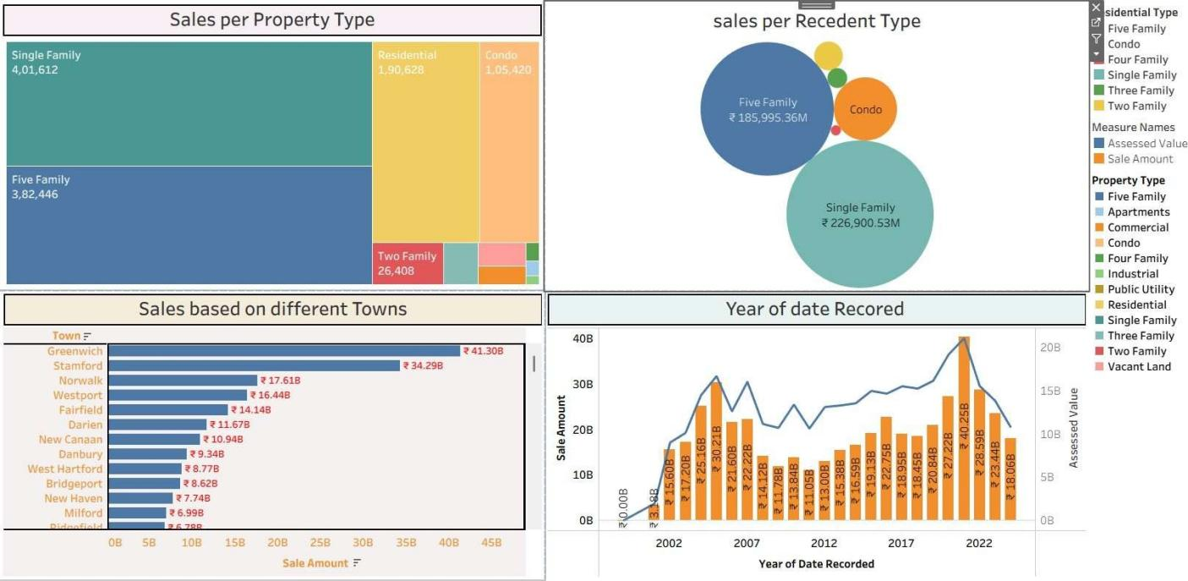
Output Screenshots: Dashboards:
Fig: Dashboard 1 for Visualization of Housing Market trend

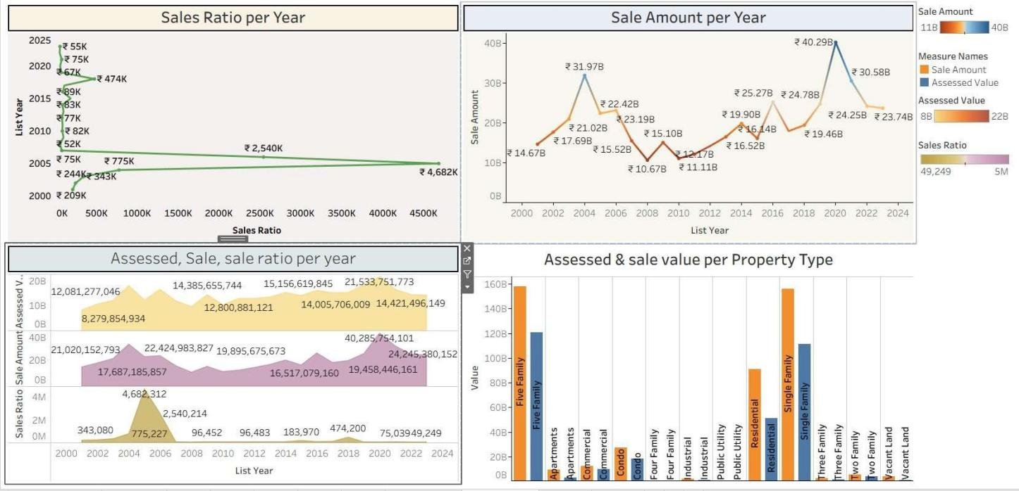
Fig: Dashboard 2 for Visualization of Housing Market trend

Story:
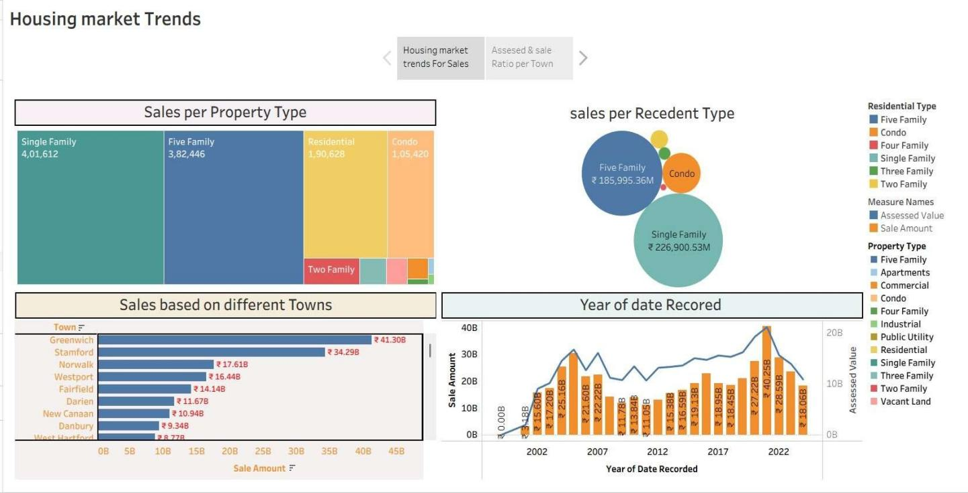
Fig: Story 1 for Visualization of Housing Market trend
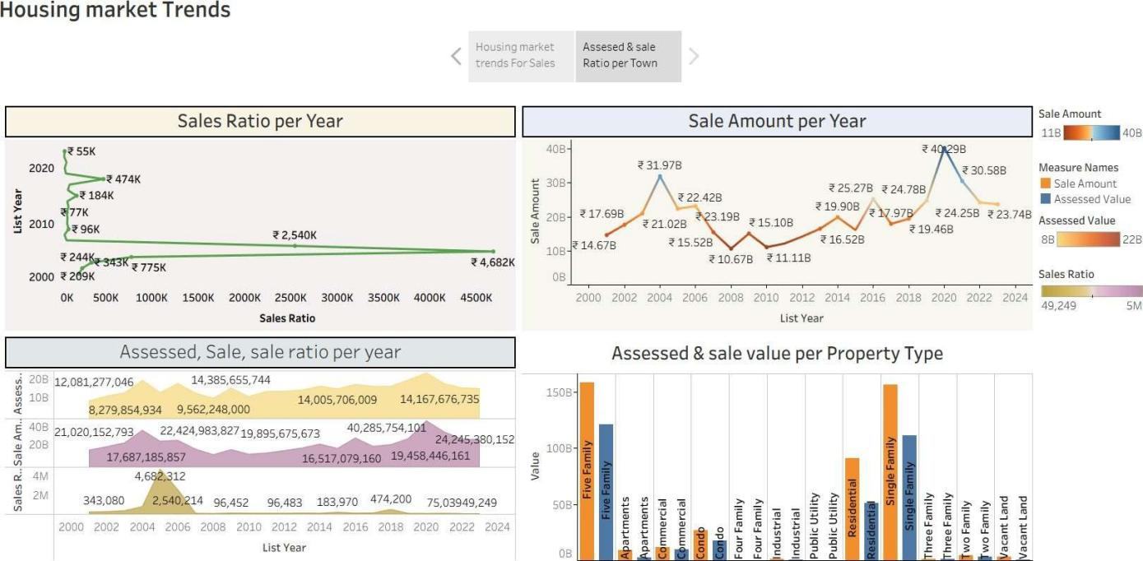
Fig : Story 2 for Visualization of Housing Market trend

Web Integration:
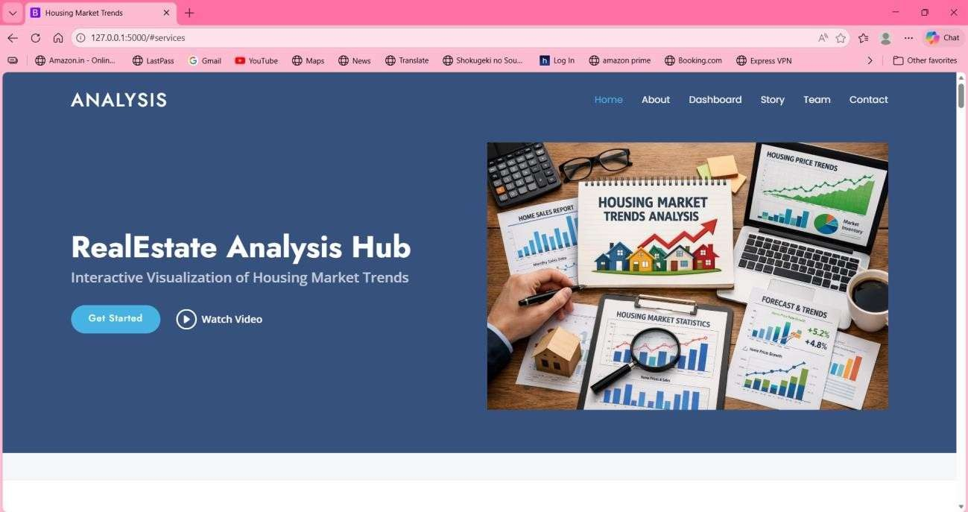
Fig : Home page of the Web

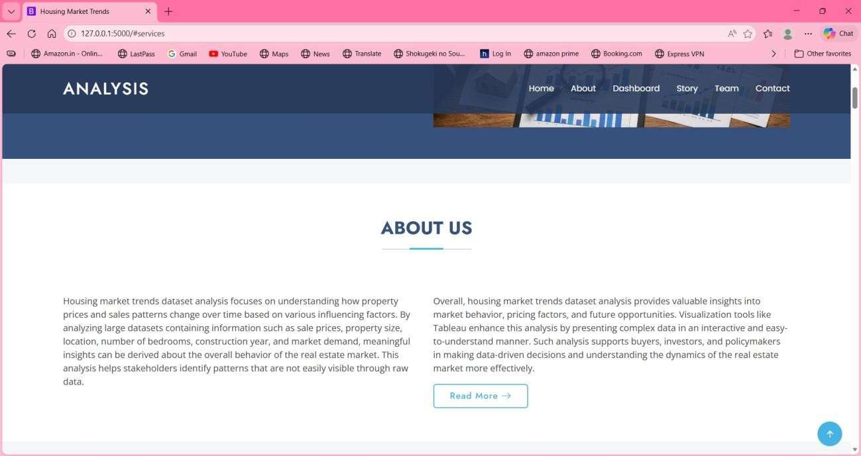
Fig : About us Section

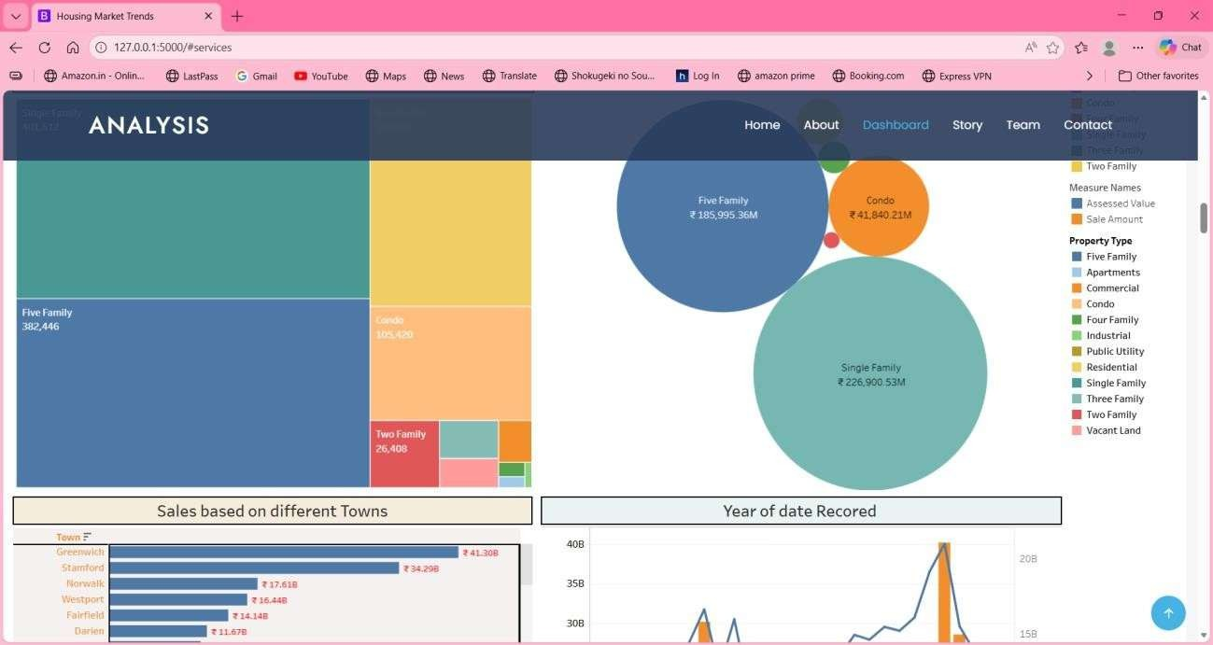
Fig : Dashboard Integrated with Web

Advantages and Disadvantages

Advantages:
- Improved Data Understanding
The project converts large and complex housing datasets into visual formats, making it easier to understand trends, patterns, and relationships between housing features and prices.
- Interactive Visual Analysis
Using Tableau dashboards allows users to interact with data through filters and charts, enabling deeper exploration compared to static reports or spreadsheets.
- Efficient Data Analysis
Visualization reduces the time and effort required to analyze housing market data and helps in quickly identifying important insights.
- Educational Value
The project provides hands-on experience with real-world tools such as Python, Tableau Desktop, and Flask, enhancing practical learning and technical skills.
- User-Friendly Presentation
Integrating the dashboard with a Flask web application allows insights to be viewed through a browser, improving accessibility.
- Scalable Design
The system can be extended with additional datasets, more visualizations, or advanced analytics without major architectural changes.

Disadvantages
- Static Dataset Dependency
The project relies on pre-collected datasets and does not support real-time data updates.
- Limited Analytical Scope
The system focuses on visualization and exploratory analysis and does not include predictive or machine learning-based forecasting.
- Performance Limitations
Handling very large datasets may affect dashboard performance and loading time.

- Manual Data Preparation
Data collection and preprocessing require manual effort, which can be time-consuming.
- Local Deployment
The Flask application runs on a local server and is not deployed on a cloud platform. No User Authentication
- The system does not include user login or role-based access control.

Conclusion
The project Visualizing Housing Market Trends successfully demonstrates how housing market data can be analyzed and presented using data visualization techniques. By collecting, preprocessing, and analyzing housing datasets, the project transforms raw and complex data into meaningful visual insights. The use of Tableau Desktop enables the creation of interactive charts and dashboards that clearly represent housing price trends and the influence of various housing features.
Integrating the Tableau dashboard with a Flask-based web application improves accessibility by allowing users to view insights through a web interface. The project emphasizes analytical visualization rather than transactional or user-centric features, making it suitable for academic and learning purposes. Overall, the project achieves its objective of simplifying housing market analysis and provides practical exposure to data analytics, visualization, and basic web integration concepts.

Future Scope
The project can be enhanced and extended in several ways in the future. Real-time data integration can be implemented to keep housing market insights updated continuously. Advanced analytical techniques such as predictive modeling and machine learning algorithms can be added to forecast housing prices and trends.
The system can also be deployed on cloud platforms to improve availability and scalability. Additional features such as user authentication, role-based access, and region-specific dashboards can be introduced. Furthermore, support for larger datasets and multiple data sources can be added to improve performance and analytical depth. These enhancements would make the system more robust, scalable, and suitable for real-world applications.

Appendix

Source Code: https://public.tableau.com/app/profile/sai.kiran.kavili/vizzes

Dataset Link: https://catalog.data.gov/dataset/real-estate-sales-2001-2018

GitHub: https://github.com/saikirankavili/Visualizing-Housing-Market-Trends/tree/main

Project Demo Link: https://drive.google.com/file/d/1W2ukdc7bxrbQLblMZ9OWszeJFFDUlGSu/view?usp=driv esdkn

